Come out & join the B.U.B.B.A. Riding Club for the…

“RYDERS FOR SKYLAR”
CHARITY RIDE
Saturday – October 2, 2010

All proceeds from the event will benefit 13-year old Skylar, who was diagnosed with Bruton’s Disease when she was born, and continues to fight the battle.

BUBBA Riding Club Event Begins at: BUBBA Riding Club
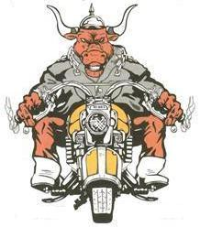
Hpt. Rds. Harley-Davidson 6450 Geo. Wash. Mem. Hwy.
Yorktown, VA 23692

Bull Island, VA Bull Island, VA
Registration opens at 11:o0AM
Ride Starts at 12:00PM

$20.00 donation per rider
Includes FREE BBQ Lunch

Prizes will be awarded at each Stop!!!

The ride will end next to Islander Scents Trophies & Engraving, 501 Wythe Creek Rd., Poquoson, VA 23662

There will be Food & Drinks, LIVE Music by the Bru-Houndz, Raffle for Prizes, 50/50 Drawing and much more…

T-shirts for the event will be on sale!
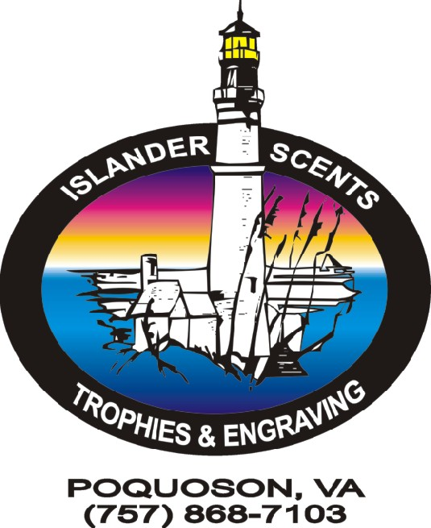


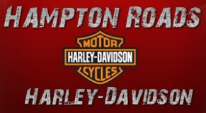

Chesapeake Bay Packing - Champs-R-Us - O. J. Smith Services

For more information, please contact:
Larry Wainwright at (757) 714-8827 or e-mail islanderscents@cox.net
or e-mail bullislandunitedbigbikesassoc@hotmail.com

